Git Commands

1. Git –version

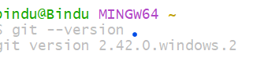

1. Git init

(observe at the end of the path it is added as master)

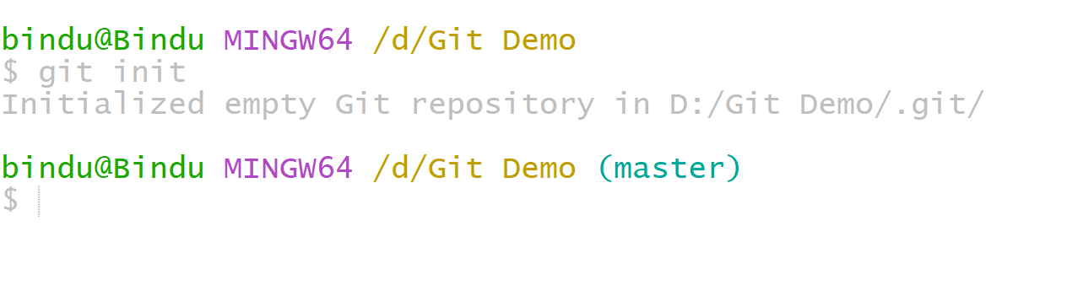

1. Touch text1.txt

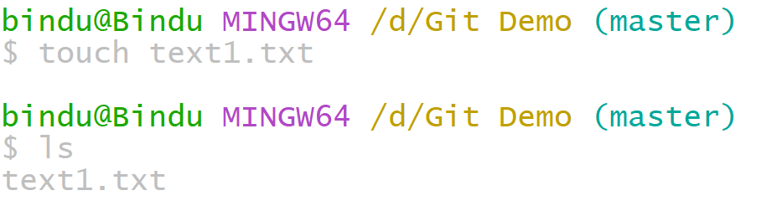

1. Git config

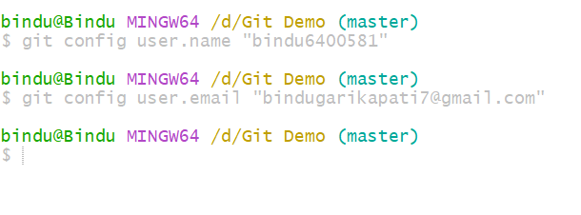

1. Git status 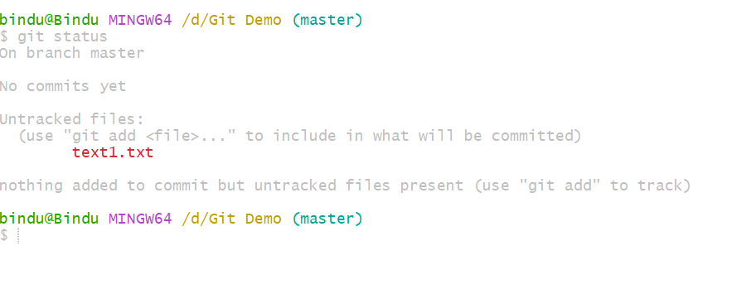
2. Git add

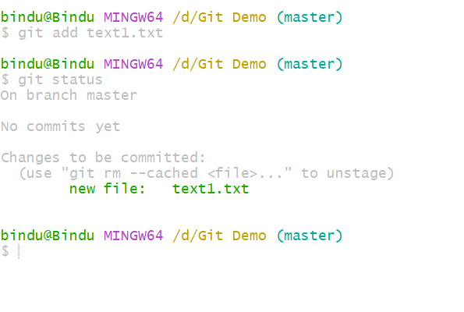

1. Git commit, followed by status and log

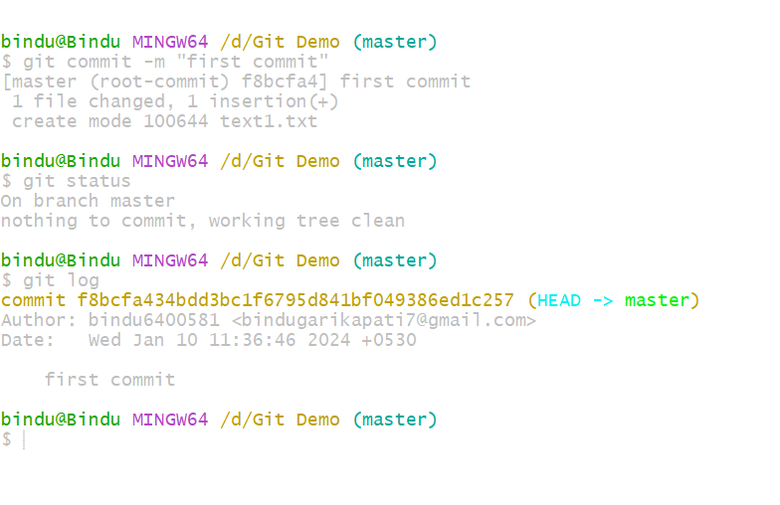

1. Creating a repository in git hub

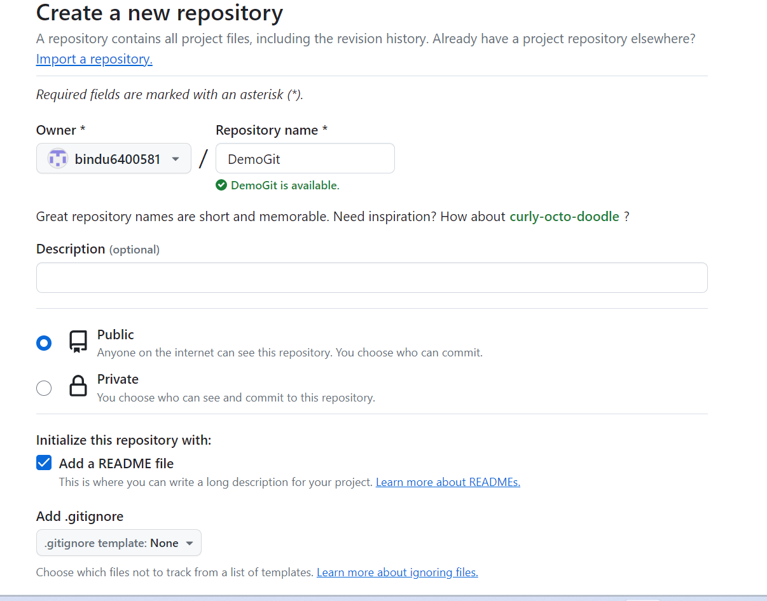

1. Adding the origin link in bash for pushing the files. Checking the remote -v to know the status of fetch and push permissions

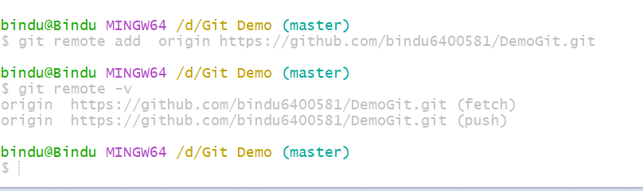

1. Git pushing for the first time

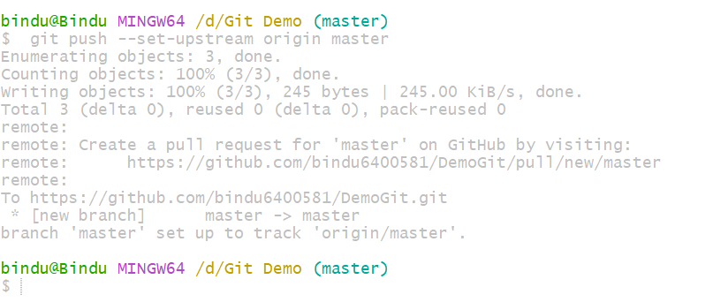

Text1.txt is added in git hub repo. Observe in the following

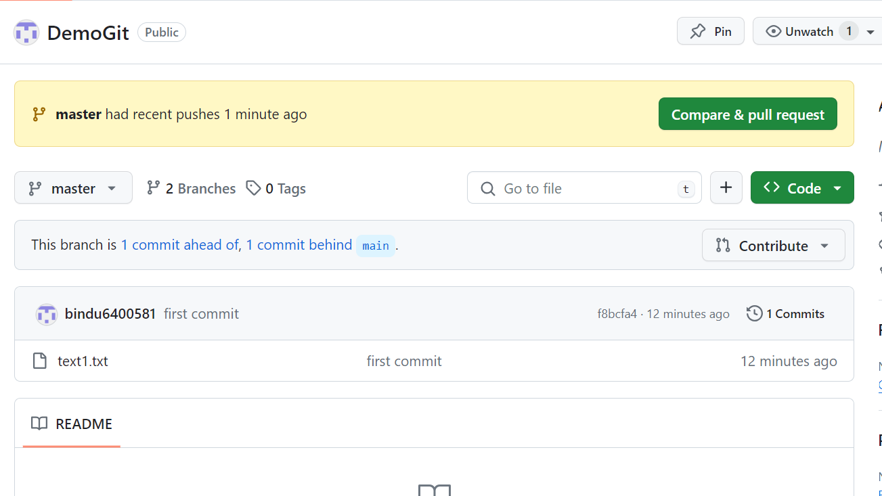

1. Git branches

Command to display the branches

Git branch: Local branches

Git branch -r: Remote Branches

Git branch -a: All

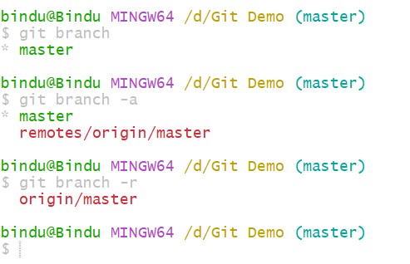

1. Creating new branch in master name b1

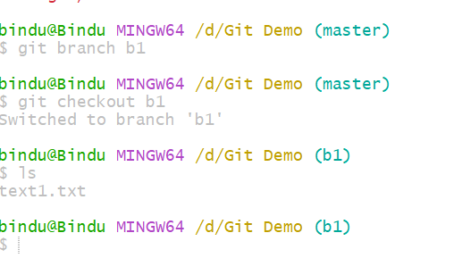

1. Create another branch b2 and create text2.txt. Check the list of files in b2

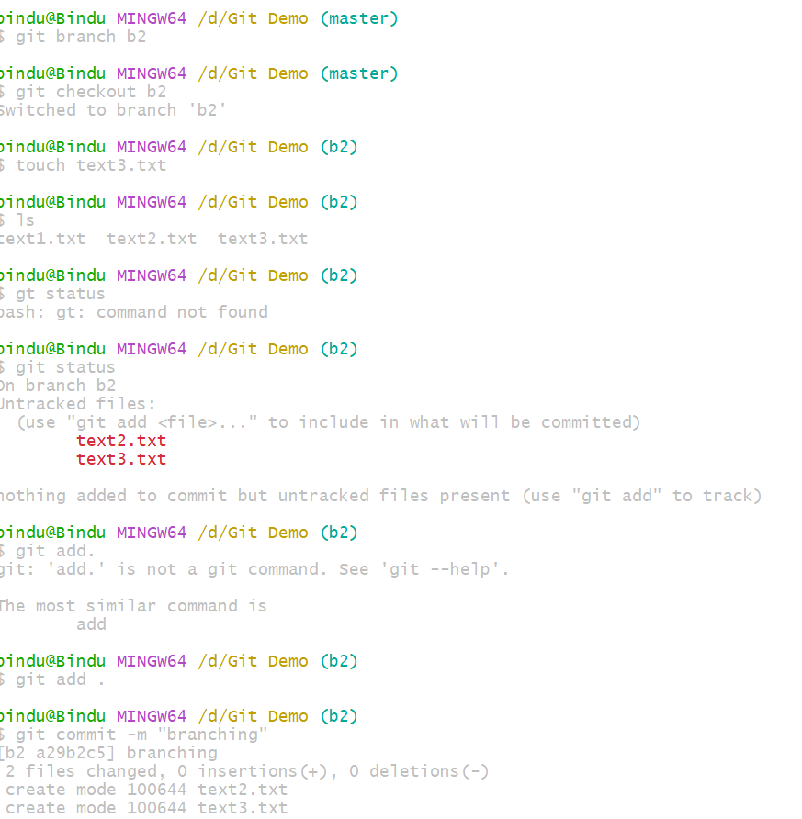

1. Always header point to most recent commits. b2 is the last commit so head is pointing to b2

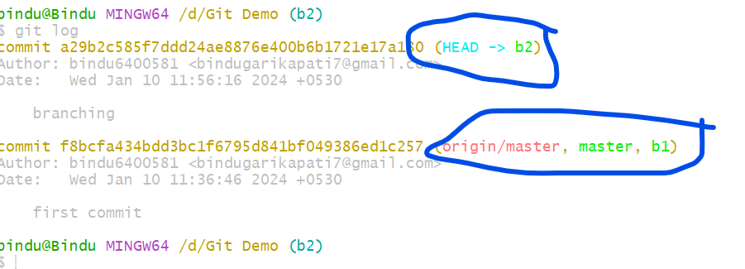

1. Observe creation of files in banches

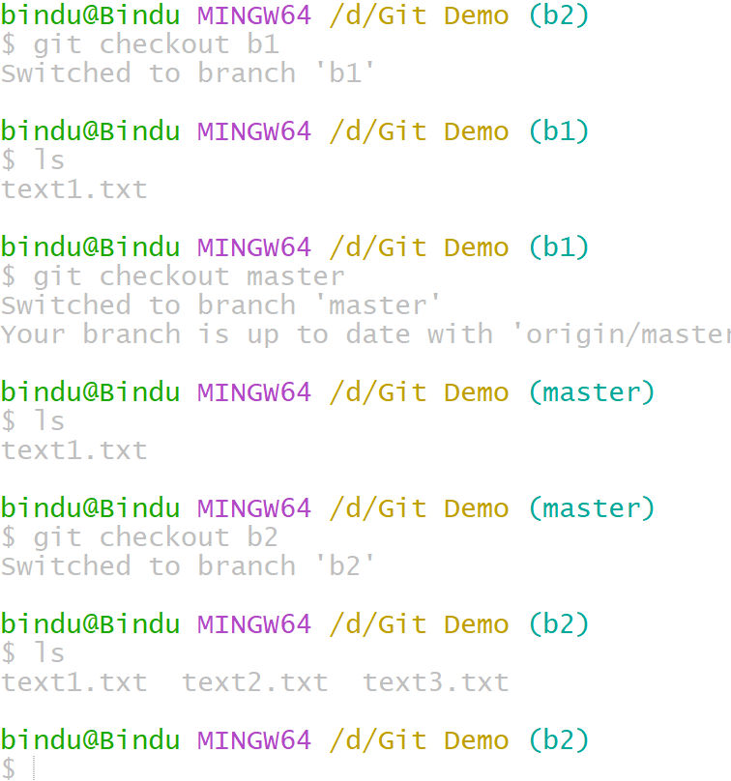

Master contains text1, text2, text3

b1: contains text1 (before committing text2 we come our=t from b2 to master and committed)

b2: contains text1, text2, text3

1. Pushing all the branches

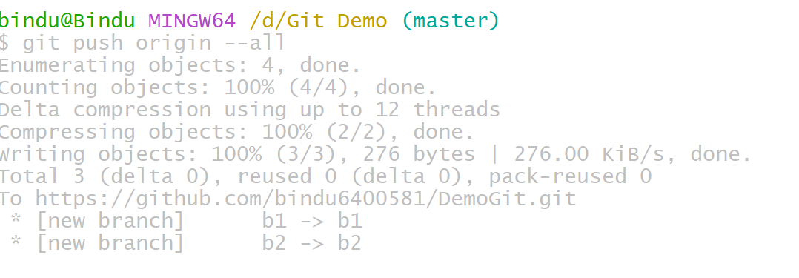

1. Deleting branch b1 in GitHub from gitbash(local machine)

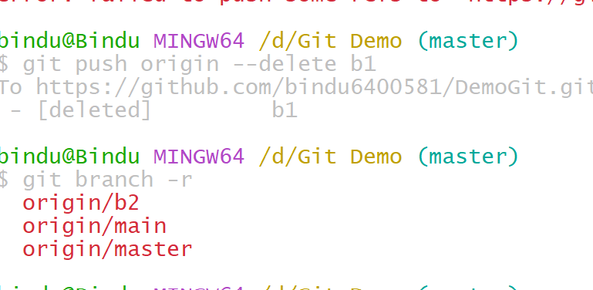

Refresh and check in the GitHub platform

1. Git ignore

Steps:

* 1. Open ur d drive and create a folder.
  2. Now go to git bash and open a file with the name .gitignorе(. is there in the beginning of the file name)
  3. Check the status using gitstatus
  4. Open now the ignore file in note pad mode
  5. Type the folder name as shown below in figure 1

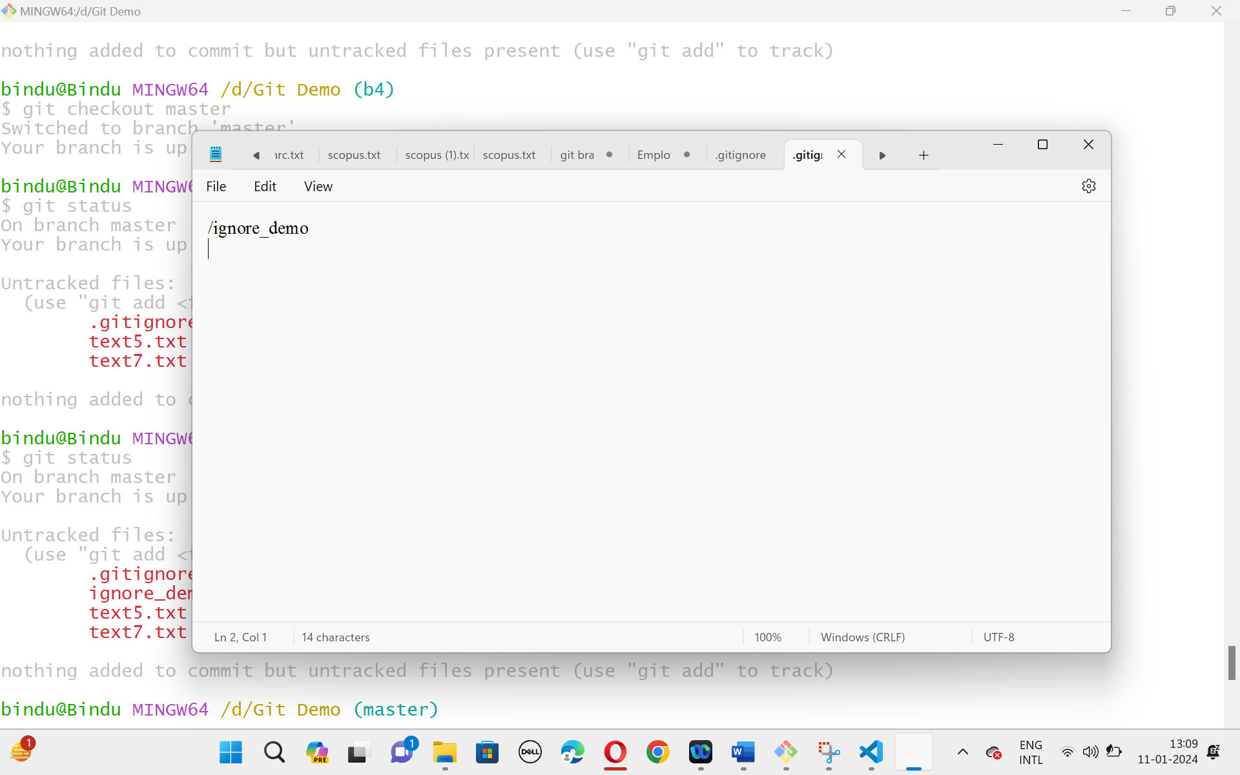

Figure 1: .gitignore file

